1. Account Management:

* SE18_PhamAnhDung_Account.Login_SequenceDiagram_v1.0

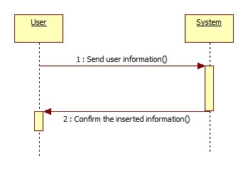

* SE18_PhamAnhDung_Account.Logout_SequenceDiagram_v1.0

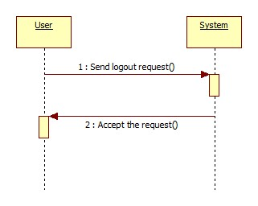

1. Staff Management:

* SE18_PhamAnhDung_StaffManagement_SequenceDiagram_v1.0

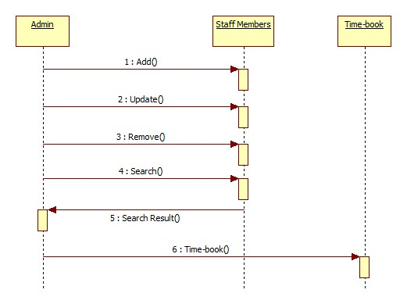

* SE18_PhamAnhDung_StaffManagement.Add_SequenceDiagram_v1.0

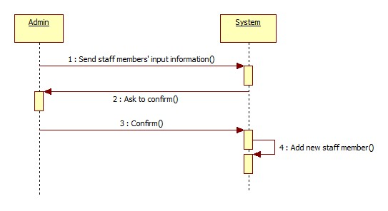

* SE18_PhamAnhDung_StaffManagement.Update_SequenceDiagram_v1.0

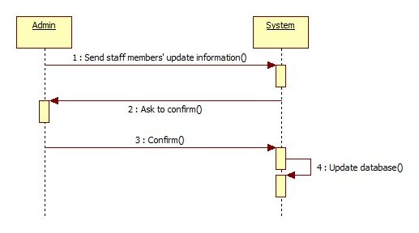

* SE18_PhamAnhDung_StaffManagement.Remove_SequenceDiagram_v1.0

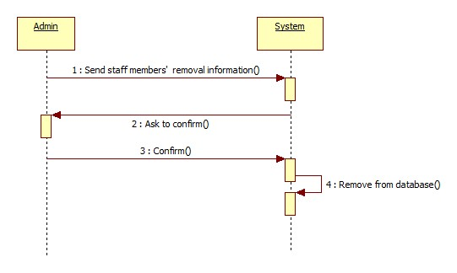

* SE18_PhamAnhDung_StaffManagement.Search_SequenceDiagram_v1.0

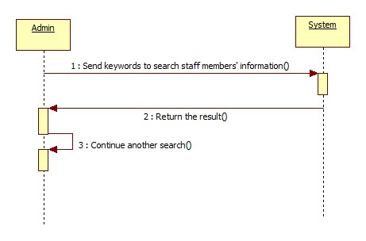

* SE18_PhamAnhDung_StaffManagement.Timebook_SequenceDiagram_v1.0

